|  |  |  |
| --- | --- | --- |
| **KING SAUD UNIVERSITY**  **COLLEGE OF COMPUTER AND INFORMATION SCIENCES Computer Science Department** | | |
| **CSC 227: Operating System** | **Tutorial# 6**  **Due: Sun, April 9 (12-1)** | **2nd Semester 1437-1438**  **Spring 2017** |

**Question1:**

Suppose the following jobs are to be executed in a uniprocessor system. Suppose context switch overhead is one time unit.

|  |  |  |  |
| --- | --- | --- | --- |
| Process # | Arrival time | Burst time | Priority |
| P1 | 0 | 5 | 3 |
| P2 | 2 | 10 | 2 |
| P3 | 7 | 5 | 1 |
| P4 | 10 | 1 | 4 |
| P5 | 11 | 7 | 3 |

Show the Gaunt chart and calculate the average waiting time for CPU scheduling:

1. Using Shortest Remaining Time First (SRTF):

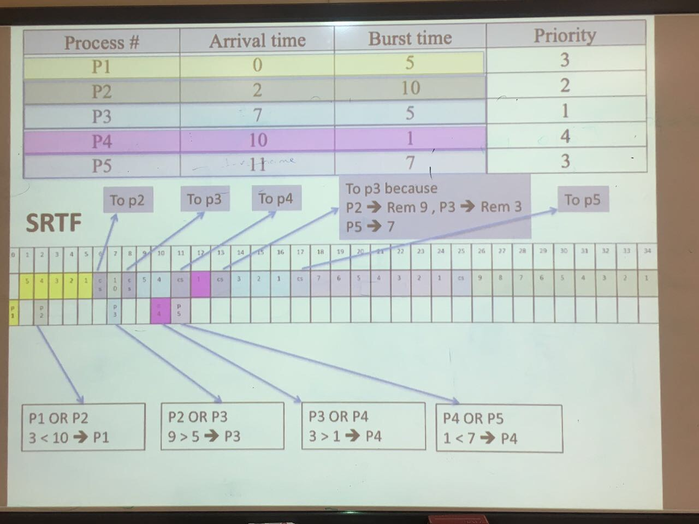

1. Using Preemptive Priority:

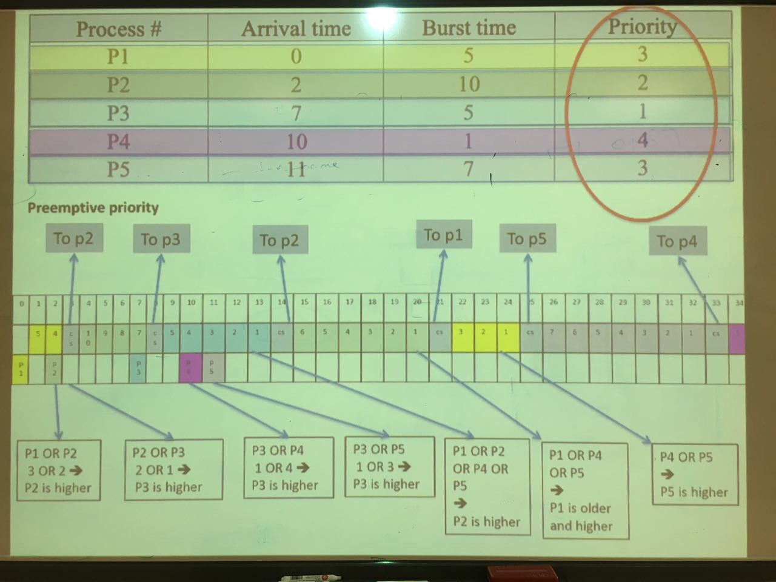

1. Using Round Robin (RR): [Time quantum is 3]

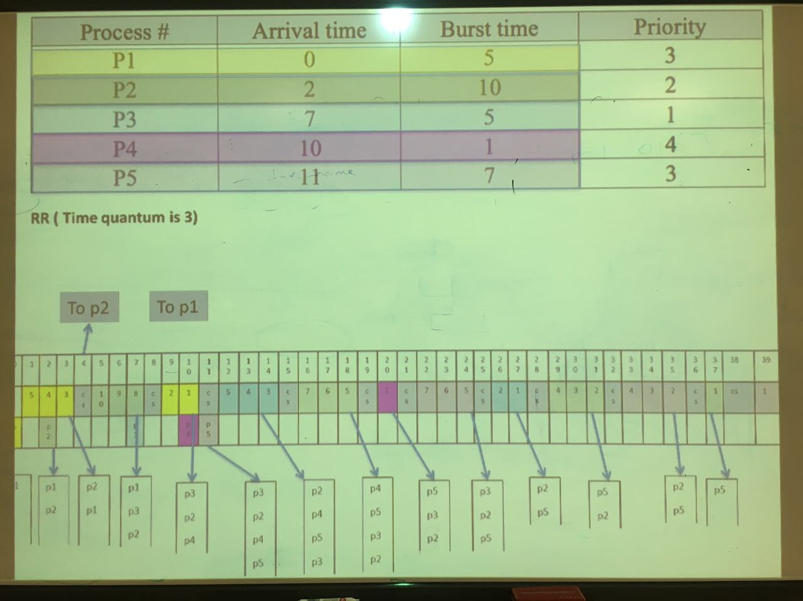



**Question2:**

Suppose the following jobs are to be executed in a uniprocessor system.

|  |  |  |  |
| --- | --- | --- | --- |
| Process # | Arrival time | Burst time | Priority |
| P1 | 0 | 12 | Low |
| P2 | 4 | 10 | High |
| P3 | 8 | 6 | Medium |
| P4 | 10 | 2 | High |
| P5 | 15 | 3 | Medium |
| P6 | 16 | 5 | Low |

Multilevel Queue with three queues numbered 1-3. The first queue has a high priority and uses SRTF scheduling, the second queue has a medium priority uses RR scheduling [Time quantum of 5 milliseconds], and the third queue has a low priority and uses FCFS. Ignore the context switch overhead.

You are required to complete the following table to show the content of each queue and running process:

|  |  |  |  |  |
| --- | --- | --- | --- | --- |
| Time | Running process | content of Q1 | content of Q2 | content of Q3 |
| 2 | P1 | - | - | - |
| 5 | P2 | - | - | P1 |
| 10 | P2, P4 | P4 | P3 | P1 |
| 15 | P2 | - | P3, P5 | P1 |
| 20 | P3 | - | P5 | P1, P6 |
| 25 | P3, P1 | - | - | P1, P6 |
| 30 | P1 | - | - | P6 |
| 35 | P6 | - | - | - |